**The University of Newcastle**

**School of Information and Physical Sciences**



Group 3

**Work Integrated Learning**

**COMP3851A – Trimester 1, 2024**

**Project Plan**

*Authors:*

1. Kennedy Tan (c3426446)
2. Marcus Tan Wei Jie (c3426473)
3. Diing Yang Loh (c3426449)
4. Chung Li Yang (c3426441)
5. Thi An Doan (c3438043)
6. Deegala Suhain Melitha Somasiri (c3426453)

# **UON Student Course Planner Website**

# **Background**

In the pursuit of academic excellence, the University of Newcastle (UON), Australia, has always encouraged students to plan their course schedules, and UON currently has its own course planner tool to help facilitate this. The team believes that although the tool is generally effective, it still has room for improvement. Therefore, as part of the Bachelor of Information Technology's final-year project, our team has embarked on the development of a new course planner website. This tool is specifically designed for students pursuing the same degree at UON’s Singapore campus.

We have identified a need for this project after observing that the existing course planner, while functional, does not fully cater to the unique needs of students in Singapore. These students have fewer course options compared to their Australian counterparts. Moreover, if the user wanted to check the availability of their desired courses, they would have to search through numerous courses, which may lead to frustration.

The successful completion of this project will not only fulfill our team’s final-year project requirement, but also have the potential to enhance the academic planning process for all students pursuing the same degree at the Singapore campus. Some features that the team is going to develop are drag-and-drop courses, allow students to choose an alternate path, and track their study progress. Whenever possible, the program fills in the pathway to graduation automatically, and consequently, students can complete incomplete parts manually. The system will check if the choice of courses is valid and display an error message if the prerequisites are not met.

Figure 1: UON Current Course Planner Website

## **Aims**

In one year, the primary aim of this project is to develop a user-friendly course planner website that is tailored to the needs of students pursuing the Bachelor of Information Technology (BIT) degree at the Singapore campus.

Specifically, our team aims to:

**Aim 1:**  **Improve user experience (UX)** –Design an intuitive interface that makes it easy for students to plan their course schedules.

**Aim 2: Provide relevant information** – Ensure that the course information provided is relevant to the Bachelor of Information Technology students at the Singapore campus, thereby preventing information overload.

**Aim 3: Enhance accessibility** –Make the website accessible on various devices such as laptops, tablets, and smartphones. This allows students to plan their courses anytime, anywhere.

**Aim 4: Facilitate sharing** - Incorporate features that allow students to easily share their course schedules with others.

By achieving these aims, our team hopes to not only fulfill our final year project requirement, but also contribute to the academic success of our current and future peers.

## **Methods and Activities**

A course planner is a tool that provides a graphical representation of the organization and structure of your course and helps you plan how to achieve your academic goals by deciding what courses you will take each semester (The University of Melbourne, n.d.). The following is a breakdown of all functionalities required for the project:

* Account creation
* User authentication to the website
* A search function for available courses
* A drag and drop function to add courses
* The option to delete courses
* A content management system (CMS), where the administration team can modify the interface to suit their needs on how the students will navigate the website.
* Auto-complete function for compulsory modules required for graduation.
* Course dependency checking function
* Contacting the admin page for bugs or questions
* Sharing feature

To develop our system, we would need to develop both front-end and back-end systems to store user information, session data, and other application data (Ramotion, 2023).

Figure 2: Website Dashboard

*Framework*

Our team will use React JS, a famous library used to develop front-end development. Due to react having a modular structure, it allows the team the flexibility to save time. As our team members have a proficient knowledge of JavaScript, it makes it easier to learn the framework in a few days, according to Vaghela (2023). However, the team would still need to perform a substantial amount of self-learning to learn how to use React JS. Being open source, React JS offers many free libraries to choose from to improve our website. It also allows us to make modules of many features that can be reused for other features. This is useful for creating a content management system where the admin can change the location of the navigation bar and images of the User Interface (UI) (Raju, 2023).

*Backend*

As the team plans to implement account creation and authentication features for our website, we will require a database to store their emails and passwords. This database will be responsible for securely storing user credentials, including email addresses and passwords. Additionally, it will retain any modifications made to users' course planners, such as course additions or removals. Furthermore, our database will house all the data on available courses. This centralized storage system will ensure seamless user experiences and efficient data management.

When selecting the appropriate database for our needs, considerations such as data management, concurrency, and data complexity are important (Patel, 2023). Our team has chosen to use Firebase, which aligns with our requirements. In addition, Firebase offers robust debugging capabilities through its 'Crashlytics' service, efficiently facilitating the detection and resolution of crashes. Furthermore, being developed and maintained by Google, Firebase boasts high reliability as it is supported by stringent encryption measures.

*Programming Languages*

Our team will use several programming languages such as HTML, CSS, and JavaScript. HTML creates the structure of the website, while CSS creates the design of the website. Moreover, JavaScript provides interaction features for the user which can display data dynamically.

*Activities*

To develop a website that offers an intuitive interface, the developers must be familiar and have a deep knowledge with both User Interface (UI) and User Experience (UX) design. Therefore, the team will conduct user research to better understand students’ needs, behaviours, and problems. This will help in designing a product that aligns with the user’s mental model. The team will also adopt an iterative design process where the interface is continually refined based on feedback provided by other team members. Lastly, prototyping will be performed to assist the team in the initial usability testing of the interface.

Our team will gather the relevant course information as well to ensure the course planner website meets the needs of BIT students at the Singapore campus. This data will be sourced either directly from the course coordinator or extracted from the official PSB-UON website. By focusing solely on BIT students' requirements, we guarantee the information provided is tailored to their curriculum, thereby avoiding unnecessary clutter, and enhancing the user experience. Finally, to facilitate easy access and seamless integration, our team will store all the course information in Firebase as our chosen database.

To enhance the accessibility of our website, our team will have to develop and implement a responsive design using CSS and JavaScript. In this case, the layout and content will automatically adjust to match the device's screen size and resolution (G, 2023). Our team will also optimize the user interface elements for mobile devices as well as perform cross-browser testing to ensure our website works consistently on all Internet browsers. Performance optimization will also be done to accommodate users who have slow Internet or less powerful devices, by minimizing file sizes and using compression techniques to improve load times across all devices.

To enhance the sharing functionality of our course planner, our team will integrate a feature that enables users to effortlessly generate a unique URL link. When activated, this function will compile the sharer’s course schedule details into a static web page, ensuring the information is easily accessible to recipients. Importantly, to prioritize security and prevent unauthorized alterations, the shared web page will be designed to restrict any form of interaction with the course plan set by the sharer. This approach guarantees that the integrity of the shared course schedule remains intact, providing users peace of mind when sharing their academic plans with others.

*Team communication and progress tracking*

1. **Slack**

Our team has chosen to utilize Slack as a communication tool due to its reputation for fostering high-quality communication and collaboration within the team. Recognized within the commercial industry, Slack offers a versatile platform that allows team members to articulate ideas effectively through the sharing of files, pictures, and videos. Additionally, Slack’s organized channel structure helps to prevent ordinary, everyday conversations from burying important project details.

1. **Notion**

Notion integrates documents, databases, notes, and collaboration tools into an all-in-one workspace. Moreover, it can be used as a repository for project documentation, meeting notes, and collaborative planning. The notion platform provides features for real-time discussion, ideas discussion, managing deadlines using project roadmaps, and updates on project progress.

1. **Git and GitHub**

With Git, it’s possible for multiple developers to concurrently contribute to the same project, avoiding conflicts between modifications made to the source code. Changes can be shared effortlessly and merged smoothly, maintaining a comprehensive history of alterations. Furthermore, Git empowers team members to operate independently on distinct sections of the codebase, fostering enhanced collaboration.

1. **Gantt Chart**

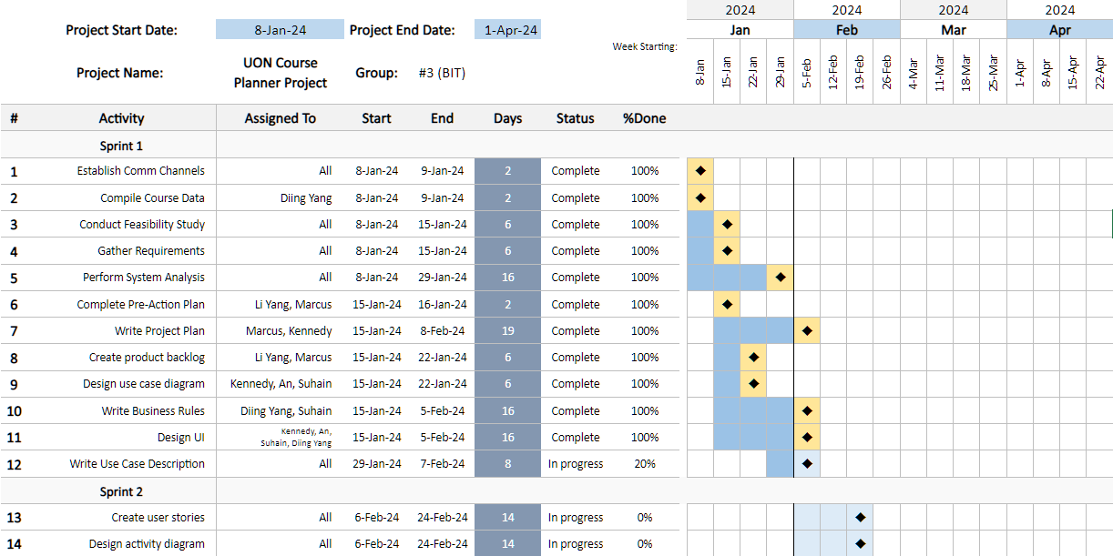

Figure 3 - Gantt Chart

With the Gantt Chart, the team can effectively follow the plan laid out and accomplish the goals and tasks assigned to them within 1 sprint cycle or 1 month. Any activities yet to be completed are continued in the following sprint cycle. When an activity is deemed to be completed, the endpoint of the activity is marked golden to signify as such.

## **Ethics, intellectual property, and confidentiality considerations**

As the team plans to implement account creation and authentication features, there will be confidentiality considerations such as data protection and account security. Fortunately, Firebase keeps detailed account activity logs and encrypts sensitive user information, such as their passwords and emails.

Our course planner website prioritizes user privacy by implementing stringent measures. Although necessary data is collected for functionality, we guarantee confidentiality through transparent privacy policies, robust encryption, and compliance with data protection regulations. This approach aims to build trust, providing users with a secure and personalized experience. Additionally, access to our website will be restricted to students with valid UON email accounts; the email domain name must end with uon.edu.au. Hence, minors and other non-authorized people will not be permitted to create accounts or access our platform**.** Moreover,there will not be any risks involved when someone uses our software.

## **References**

Chu, R., Nehoran, B., Ogunlana, A., & Leung, D. (n.d.). *TigerPath helps Princeton University students plan out their four-year course schedules.* TigerPath - Four-Year Course Planner. <https://www.tigerpath.io/>

G, N. S. (2023, December 7). *The Art and Science of Web Designing: Crafting Digital Experiences for a Connected World*. LinkedIn. <https://www.linkedin.com/pulse/art-science-web-designing-crafting-digital-connected-s-g-%E3%83%8A%E3%83%93%E3%83%A4--jmfyc/>

Hanna, K. T., & Rosencrance, L. (2023, May). *What is Google Firebase?* TechTarget. <https://www.techtarget.com/searchmobilecomputing/definition/Google-Firebase>

Patel, R. (2023, September 16). *Top Local Databases for React Native App Development*. MindInventory. <https://www.mindinventory.com/blog/top-react-native-databases/>

Raju, M. (2023, February 24). *30 Best Web Development Frameworks For 2023*. LambdaTest. <https://www.lambdatest.com/blog/best-web-development-frameworks/>

Ramotion. (2023, August 22). *The Role of Database in Web Application Development*. <https://www.ramotion.com/blog/database-in-web-app-development/>

The University of Melbourne. (n.d.). *My Course Planner*. <https://students.unimelb.edu.au/your-course/manage-your-course/planning-your-course-and-subjects/faculty-course-planning-resources/my-course-planner#about>

The University of Newcastle, Australia. (n.d.). *Course Planner*. <https://planner.newcastle.edu.au/app/home>

Vaghela, B. (2023, February 2). *The Benefits of Using React Native for Mobile Development*. IEEE Computer Society. <https://www.computer.org/publications/tech-news/trends/benefits-of-react-native>